Interventions, speculations and correspondences between design and anthropology in the city:
a carioca experience.

Zoy Anastassakis
Universidade do Estado do Rio de Janeiro - Escola Superior de Desenho Industrial

Introduction

Seeking to explore the dialogical interface between design and anthropology, we approach the center of the city of Rio de Janeiro, in Brazil, as a theme and field of a work that involves research activities, teaching, and university extension. Starting from the Superior School of Industrial Design, State University of Rio de Janeiro (Esdi/UERJ), where we created the Laboratory of Design and Anthropology (Laboratório de Design e Antropologia, LaDA), in partnership with the Department of Anthropology of the Institute of Philosophy and Social Sciences at the Federal University of Rio de Janeiro (IFCS/UFRJ), we have investigated, since the beginning of 2012, via practical and theoretical activities, the possibilities for combining modes of knowledge production in design and anthropology.

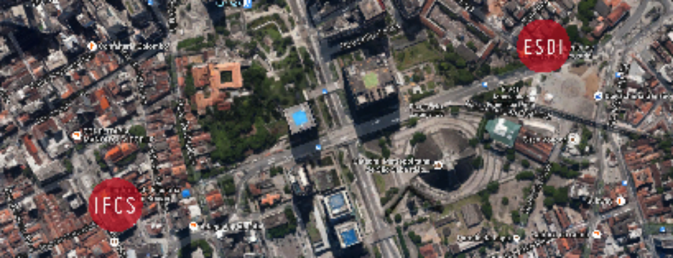
Aerial view of part of the city center.

Through a process of intense transformation owing to the preparation of large sporting events based in the city, such as the Football World Cup in 2014 and the Olympic games in 2016, Rio de Janeiro seemed the ideal environment for the establishment of an experimental inquiry that brings together the two disciplines. Situated in the historical center of the city, Esdi and IFCS meet in the epicenter of a region that condenses many of the challenges experienced by all of Rio de Janeiro today.

Thus being, alternating fieldwork and design laboratories, using hybrid processes between anthropology and design, we seek to promote interactions with the inhabitants who are willing to speculate (DiSalvo, 2012; Dunne and Raby, 2013) about emerging questions and alternative ways of consideration and imagination (Ingold, 2000; Ingold and Hallam, 2007) in terms of this urban environment, distinct from those proposals made by the municipal management and by private initiatives, that tender large projects of urban ‘requalification’ of the area.

Creating what we call ‘conversation dispositifs’ (Anastassakis, 2013), we have invested in mixed activities between fieldwork and design labs in search to create a dialogue in/with the city and its inhabitants, so that the arising questions can give a place of collective imagination of alternative possibilities (Hunt, 2011) for the city.

In this paper, I present the accomplished work under my coordination over the last two years. Beginning with some experiences of speculative intervention in the urban environment of the historical center of Rio de Janeiro, I comment on the experimentations realized, all of them informed on the theoretical and procedural framework presented by the emerging field of design anthropology (Gunn, 2009; Gunn and Donovan, 2012; Gunn, Otto and Smith, 2013; Halse, 2008, 2014; Halse, Brandt, Clark, Binder, 2010; Ingold, 2000, 2011, 2013: Ingold and Gatt, 2013: Marcus and Rabinow, 2008; etc).

Why the center of the city?

Esdi possesses its own campus, located in the historical center of the city of Rio de Janeiro, in the neighborhood of Lapa. Occupying a large area, viewed from above its terrain seems to represent a major urban void. The street on which the school is located connects Lapa, the traditional bohemian neighborhood that houses the old aqueduct of the city, to Cinelândia, the large square surrounded by the National Library, the National Museum of Arts, the Municipal Theatre, and the City Council.

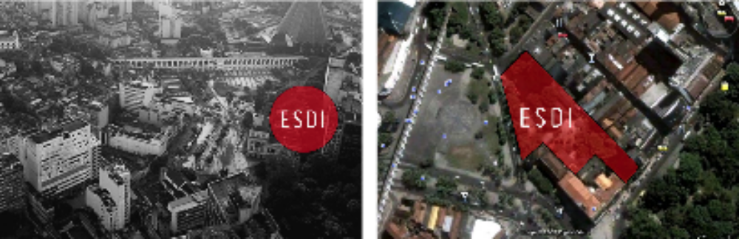
Aerial view of the center of the city where Esdi is located. Aerial view of Esdi campus in Lapa.

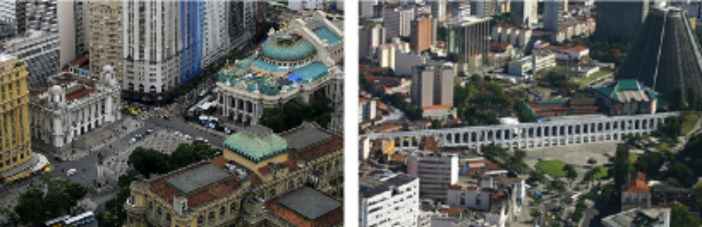
Aerial view of the Cinelândia square. Aerial view of Lapa and old aqueduct across the square.

On the street Evaristo da Veiga, where the entrance to the school is located, we meet the headquarters of the military police, where it’s been since its placing in the XIX century. Occupying a near totality of the left side of the street, the headquarters were under threat of implosion, proposed by the sate government, who claimed inadequacy of the installations for the police current necessities. Across the street, in front of the main entrance of the barracks, most of an entire block was demolished to build a large business complex under construction.

On Passeio street, which borders the depths of the grounds of the school, there are various old buildings undergoing the remodelling process, with an eye towards new uses. Among them, some of the traditional cinemas of the area have been renovated, housing today from evangelical churches to department stores and other sort of shops.

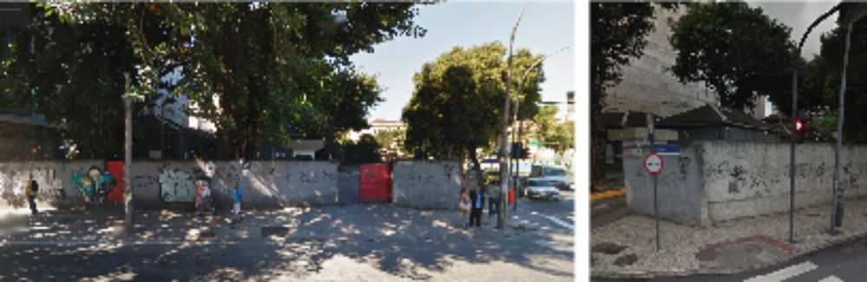
Esdi walls and main entrance as viewed from across the street. Another view of Esdi walls.

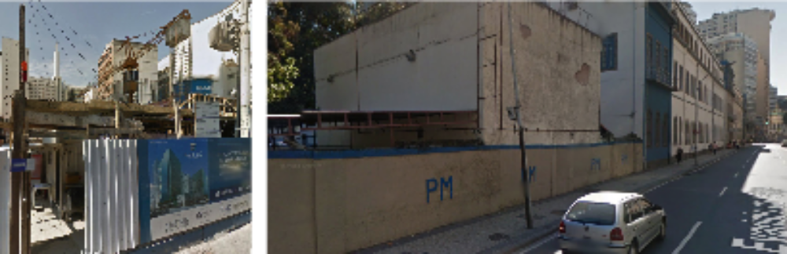
One of the many construction sites. XIX century headquarters of the military police, in front of Esdi.

Completing fifty years of existence in 2013, the school didn’t have legal ownership of the land where it was installed in 1962. So it could seem to be yet another target for the real estate speculation that surrounds the region. Considering that the municipal administration has worked intensely around a large revitalization project in the central area of the city - organized around an axis that connects the Port Zone to the region of Lapa, at the other end of the center - and that the school is situated, therefore, in the epicenter of a immense process of urban transformation; it seemed to us that it was the appropriate moment to begin an experimental research project that would approach the center of the city as subject and field of work.

Thus in 2012, we began of a series of initiatives that led to the creation of a research lab in design anthropology (LaDA) (Anastassakis, 2013), a research environment that has as a principal subject the center of the city, and as the main objective the experimentation on the conjugation between modes of knowledge production in design and anthropology. Informed by the literature produced in the emerging field of design anthropology, we see then, that the city presents issues that favors a joint experimental inquiry combining anthropology and design.

Thus, in partnership with Barbara Szaniecki (designer and researcher, PhD, Capes, Esdi/UERJ) and Karina Kuschnir (anthropologist, adjunct professor/researcher, PhD, IFCS/UFRJ), we set up a project proposing the creation of a research lab in design anthropology. Taking on as a theme and principal area of investigation the environment where we encounter, we seek to correspond (Ingold, Gatt, 2013) to the questions that traverse the city. Cause this city, beyond being where we work, is where we are, before anything else, inhabitants.

Karina comes from a long trajectory of research in urban anthropology, that now has suffered a realignment due to the insertion of drawing as a central strategy for the research development and presentation. Barbara, a designer has a history of research and activity in visual representations of political and social movements, and I, a designer with a post graduate education in social anthropology, who completed a PhD research focused on Brazilian design (Anastassakis, 2014), also having acted professionally as a designer, in the areas of graphic design, production design, strategic design and design thinking. Thus three were united at two education and research institutions based in the center of the city - one of them a design school and the other one an anthropology department -, we started joint research investigating the place where we are, between Esdi and IFCS, respectively located in Lapa and the Largo de São Francisco.

We work with our students in the classroom as and with scholarship students (who form a group of approximately fifteen). As such, the proposals made in the regular courses and the results produced by the students complemented the exercises that were accomplished with the research group. Besides that, we worked on reading groups and developed projects of university extension. All activities articulated around a conjugation between design, anthropology, and the city.

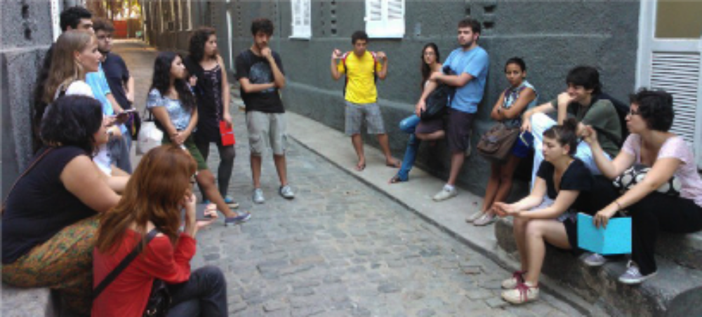
Group of students gathered just after a walk through the center of the city in fieldwork.

Thereafter, I comment on some of what we did, concentrating on the activities conducted by me through Esdi, while at the same time focusing on the proposals in which gained centrality the construction of materials that could support the fieldwork. Thus opening space to exercise the collective imagination in the field, from which we return to the school seeking to speculate about alternative ways of life in the city, a process that creates new insights, and therefore, other alternatives. This takes us back to the streets, in an open ended process of speculation, where central interest resides in the experimentation around the ways of conjugation between design and anthropology to service the common questions in the city.

Where are we?

We began the work seeking to understand the environment where we met, what we did in it, and what the others - inhabitants, frequenters, and passers by - also did in and understand of that place. In that moment, the school went through a complex process of regularization of land possession, at the same time that it completed fifty years of existence. Due the fact that it all happened in an area of the city affected incontrovertibly by the process of urban ‘regeneration', proposed by the government in alliance with private initiatives, we thought nothing better than to assume the challenge of working on issues involving all of us, in that place, in the city.

Beyond everything, it seems that this proposal could facilitate a dislocation of the way in which we teach our students to design. Being less interested in preparing them for the development of design projects in the current fashion; we understand it to be fundamental, before anything, to train our students to develop an attention or sensibility in relation to what is near, and to confront these public and common questions, that can be taken as challenges of design.

Additionally, the questions, ‘where are we’, ‘who are we here’, ‘what can this place be’, ‘how would it be if it were another way’, ‘how to correspond with the rest of the population to the challenges that affect us’, coming from a design school, could approach the design students of anthropology, in a different way that has been practiced by the design market, where one determined concept of ethnography is established as a mere research tool in design processes, what we would consider to be a problematic reduction.

Firstly, still in 2012, in a regular graduate course during 15 weeks, I proposed to the students a series of walks around the school, looking to find out about what happens there. Experimenting in doing fieldwork by drawing, we perceived that to be with a pencil, pen, and paper, sometimes in groups, would facilitate the interactions with the people who approached, asking what we were doing, who we are, and why we draw.

We perceived that the artifacts (notebooks and pencils) that we used to draw, just as the images that we produced by drawing, shortened the distance between us and the others, opening space for conversations about our activities, about what was represented in those drawings, and about our own life in the city. So, we decided to invest more profoundly in an experimentation around what we named ‘conversation dispositifs’ (Anastassakis, 2013), or rather, artifacts and graphic pieces that facilitate communication on the streets.

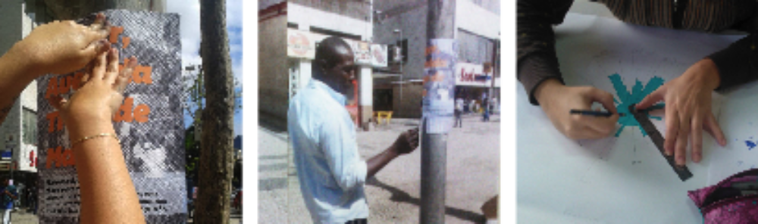
Conversation dispositifs facilitates communication with passersby. Analyzing by drawing.

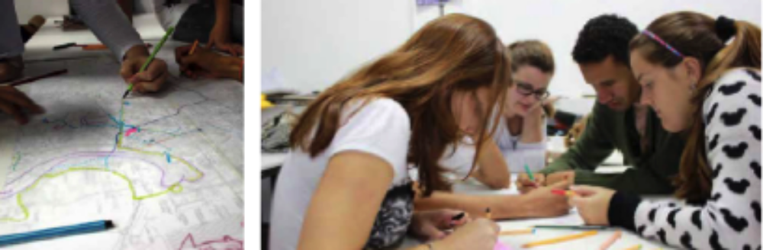
Group of students working together to discuss the fieldwork perceptions.

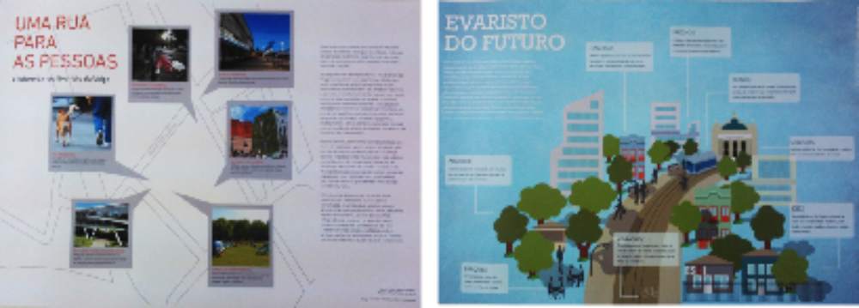
Two of the future visions developed by the students.

Returning to fieldwork, we gathered, trading impressions, drawings and photographs about what we had noted. Over the first weeks, some questions arose about what each group of students would decide to research more deeply. Among the themes; the configuration of spaces and places; the road network; the contrast between the buildings - some modern, some ancient, some very damaged; the grating doors and windows and all artifacts related to the public and private security; waste; reconfigurations of spaces and places and artifacts constructed by the moving vendors that surround the region; visual communication of trade and services; the works; unexpected uses made by people on the public spaces; urban art etc.

Having invested in going deeper into each one of these questions, the groups of students created visual representations of the perceived questions. These graphic pieces served as a base for a speculative process about alternative possibilities, that materialized in the forms of scenarios and visions (Reyes, 2010; Hunt, 2011; Lenskjold, 2011), again represented in graphic pieces (posters), that were shown on the outside wall of the school, on Evaristo da Veiga street, during a cultural week organized by the students.

The posters were shown together with the results of a workshop that was offered to outside participants (the majority being designers and students), with the theme “What if this street were mine?”. Using this question, we speculated about the alternative possibilities for our own street where the school is located, on Evaristo da Veiga. In that workshop, over a day, we invested in a fieldwork, registered what we had noticed and conversed with passers-by. Returning to the school, we imagined how the street could be, if it were another way. Beyond exposing the results, we printed a series of images collected on Google Street View, creating panels, so those who passed could interact, contributing to the imaginative exercise about the alternative possibilities for this street.

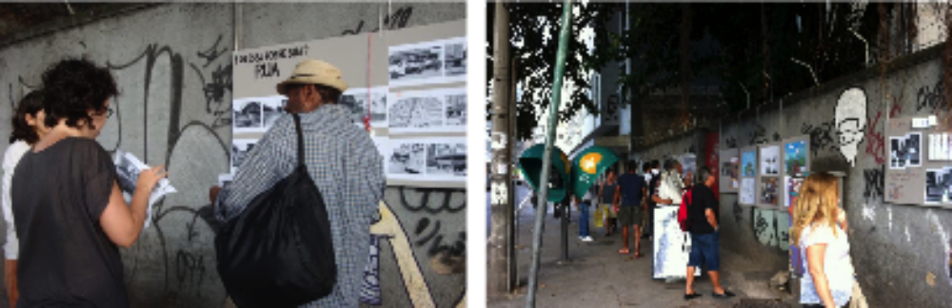
Students, teachers and passersby discuss the results exposed on the outside of Esdi walls.
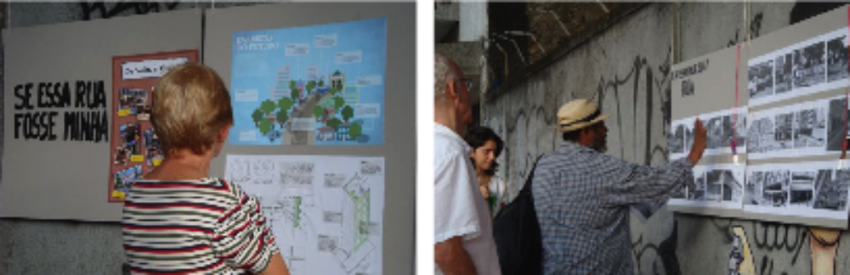
Students, teachers and passersby discuss the results exposed on the outside of Esdi walls.

The next day, we spent the afternoon in the driveway of the school, showcasing the work and interacting with passers-by. This exercise is important both in understanding how the interactions take place, mediated by the materials we produce, and how to we refine our understanding of what is at stake in that environment, not only according to our perspectives, but also according to those who pass through there.

Soon after, in the beginning of 2013, we were invited by an NGO (Agência de Redes para a Juventude) to collaborate in a program where eighteen youth from communities that were, until recently, occupied by the parallel powers of drug trafficking were incentivized to develop, over a year, a project that could be installed in their community. At the end of the cycle of project development, the youth needed a visual identity and some graphic material that could act as an intermediary in the communication with possible partners and supporters.

Accepting the challenge, over a month eighteen design students worked in pairs with young people linked to the NGO, developing visual identities and their implementation via two mappings. One with the objective of illustrating the potential impact of the project in the territory, and the other aimed at explaining the ways in which the projects developed, in terms of methodology. Among the facilities of the school and incursions to the communities, the pairs worked on the explicitation of the mechanisms of each project and in a visual communication that served as the measure for the interlocution of youth in the community and with possible partners.

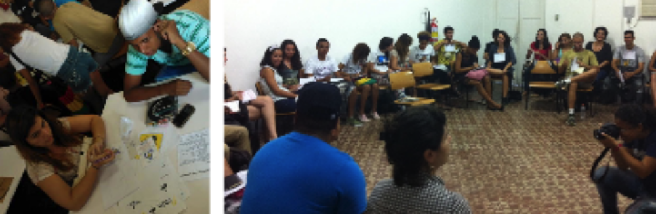
Student and partner working together. The whole group of students and partners gathered.

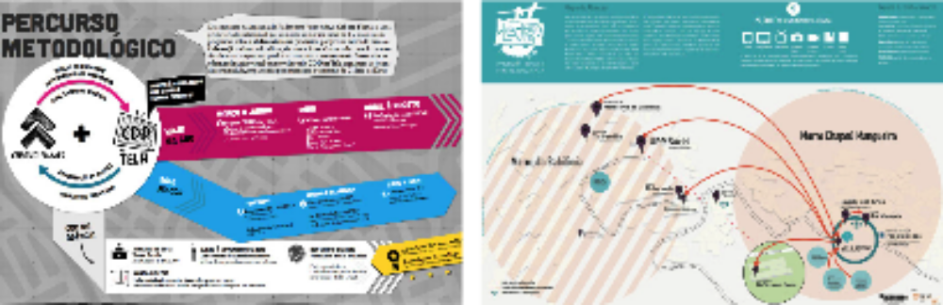
Two of the multiple final results of the collaborative work between design students and the youths of the communities.

The great challenge of this collaboration was to enable work between pairs, without letting the relationships be limited to a traditional rendering of design. Finally, we understood that this did not interest the youth of the communities, nor the students from our school. Therefore, we stimulated the development of partnerships and the exchange of experience and knowledge, in continuous transit between the design school and the communities. Happily, at the end of the month of work, some of the pairs were meshed: some of our students even became part of the groups of young people involved in the projects.

After this collaboration, still in the first semester of 2013, we were invited by a public agency that fosters entrepreneurship (SEBRAE), that started a huge program to support culture and tourism in these same ‘pacified’ communities, in order to develop design projects in partnership with the entrepreneurs of a community also located in the central zone of the city, the Morro dos Prazeres. There, again, in a regular period of third year graduate course (along 15 weeks) we developed mapping and design concepts in collaboration with our interlocutors. In this same period, some of the students also worked with the neighborhood of Lapa, where the school is located.

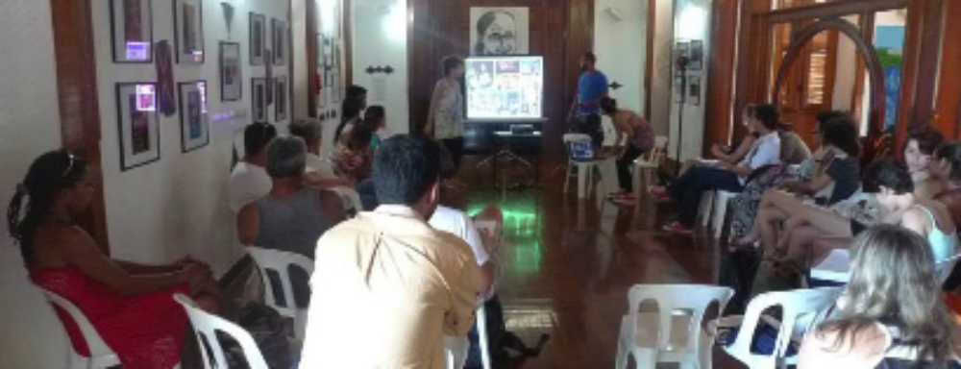
Students and partners during the presentation of the final results in Morro dos Prazeres.

In this process, the mappings had a larger goal to bring out the ways of life and creative practices in which people who with the students made contact were engaged. In this case, more than just utilize the graphic material developed in order to correspond (Ingold and Gatt, 2013) to the challenges confronted by that people, we sought to awaken the students engaged (Ingold, 2000, 2011) sensibility into the lifes of people with which they relate, in the midst of a design process. Bringing them to the field, giving them incentive to relate to other people, to get to know other places in the city, entering into spaces that, until recently, were segregated, therefore, practically inaccessible, and to realize what was at stake there, was our principal objective at the time.

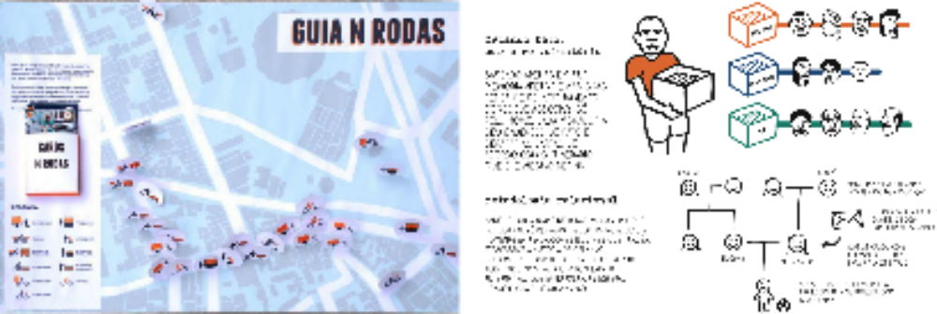
Students’ final work: in the left, salesmen with bicycles in Lapa; in the right, the voluntary postman in Morro dos Prazeres.

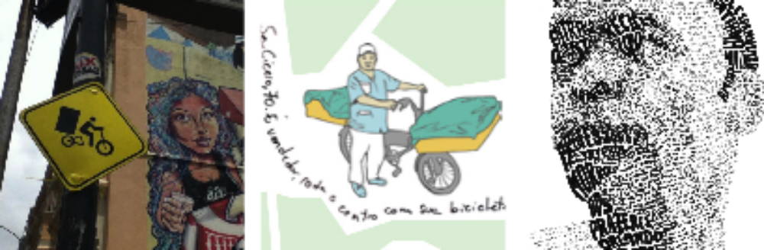
More results of the students’ projects: street interventions and subjective mapping of their partnerships.

The design exercises were the means by which we placed ourselves in these contexts, and also the way through which we understood that possible relationships with our partners could develop. If we did not reach a second stage, that we maybe expected to fulfill, namely, the development of renowned design alternatives, it did not seem problematic. Rather, we believe that that moment itself was more important to foster, experimentally, with new ways of understanding what it means to design in contemporary times, instead of to detail specifications for a further development. That being said, we shifted the emphasis of the design processes toward the process itself and to the formulation of alternatives informed by engaged and committed practices that correspond to the questions that matters.

Accordingly, through design, we give incentive to the students to enter into direct contact with the emergent questions that involve the environment we all live in. Proposing design not as end, but, instead, as a means for an anthropological approach to life, we seek to stimulate, in the students, abilities that many times seem lost amongst the processes of design, namely, a certain anthropological disposition or sensibility, that is engaged, dialogic, attentive and responsible towards life and its possibilities.

Conversation dispositifs

In the second semester of 2013, together with another group of students, we developed a series of design interventions (Halse, 2014) in the urban space that had the objective of rendering the design school visible (without signalizing and therefore almost impossible to trace, for those passing by on the street). These speculative interventions were built in stages over a few weeks, and with each step we looked to launch new clues about the school in the urban space surrounding it, while provoking curiosity and inviting people to know what was inside the walls.

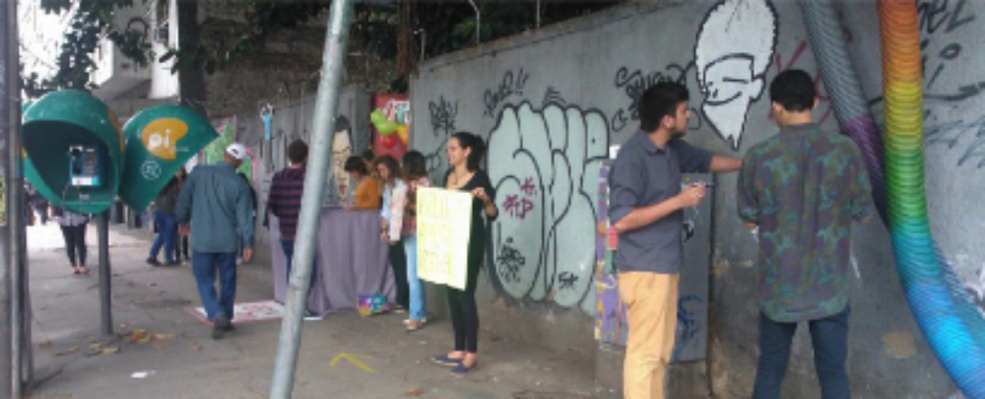
Students and passersby during multiple interventions in front of Esdi.

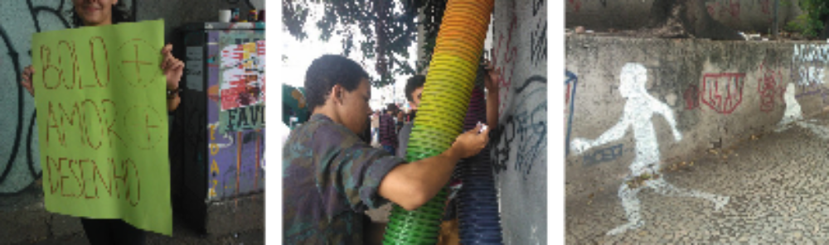
Details of the interventions developed by the students around Esdi.

In this exercise, students were encouraged both to research about the school and about Brazilian design history, seeking to create materials that could be placed into the surroundings of Esdi, provoking the attention of passersby for the design school. One of the projects was highlighted in the main city newspaper; it mimicked a mysterious advertisement commonly seen throughout the streets of Rio de Janeiro, announcing the sale of frog meat. Referencing in a humorous fashion with the mysterious marketing campaign, the students proclaimed: “we don’t have frog meat, but we do have design!”

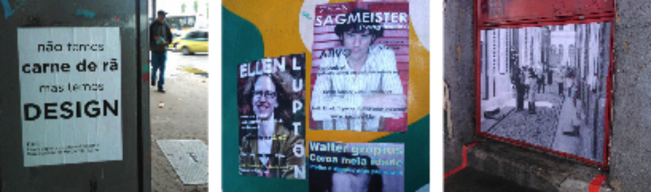
More design interventions around the school.

In 2014, again during regular third year graduate course, we proposed, as a principal theme, ways of life and the creative practices in the center of the city. On this occasion, refining what we had come to develop over the previous three semesters, we requested that the students concentrate on the ways in which people live and relate to public space in the central region of the city.

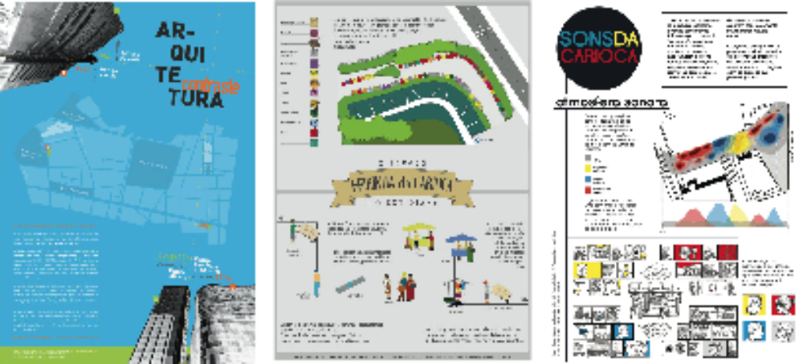
Some of the panels developed by the students as final results of the project.

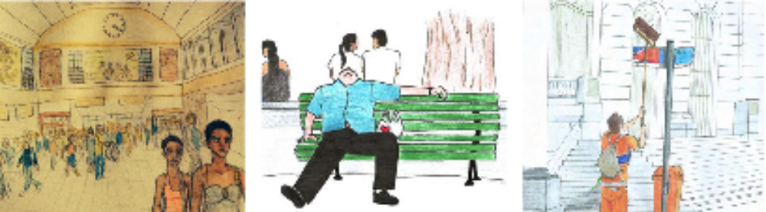
Drawings of the students’ perception of people’s practices in the city during fieldwork.

Consequently, we sought to go a bit further in relation to previous experiences, advancing in the direction of design speculation about alternative ways of life and interaction with the city, formulating design concepts by means of participant observation and speculative interventions in the field. In that process, the mediation of design artifacts produced by students gained centrality, in the measure that it could facilitate interaction with residents and passersby, as well as encourage collective imaginative exercises on alternative ways of life in the downtown area of the city. Far from being prototypes, such materials should primarily mediate conversations and stimulate imaginations. So, we could say, that we are talking about provotypes (Lenskjold, 2011).

The subject developed together with the students also inspired the organization of a seminar, made possible by the public notice of the Carioca Center of Design, an organ of the mayor’s office of the city. With this, we intend to amplify the discussion beyond our research lab; we have invitations and open calls, so that other researches and cultural agents can present their work. Beyond speeches, round tables and panel presentations, we received proposals for workshops that will be offered throughout the seminar, and we put together a mobile lab of design anthropology. Also enrolled participants were invited to develop, throughout the four days of activities, speculative interventions around the location.

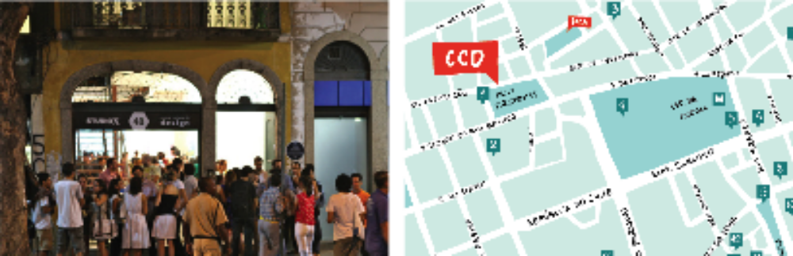
The Carioca Center of Design (CCD). Map of the city center with CCD.

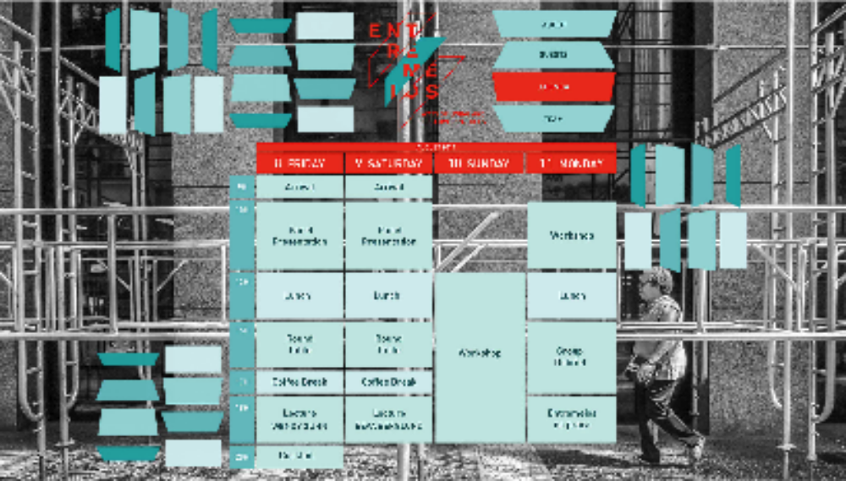
The seminar webpage showing the activities schedule (entremeios.ladaesdi.com).

With this seminar we seek to approach public management, aiming to build in a collaboratively way desirable futures for the city. Thus, we hope to cooperate for greater articulation between engaged knowledge with ways of life and creative practices of the citizens and practices of planning and management of urban life, undertaken by political representatives and techniques of public administration. It may seem a bold proposal, but we bet it is worth imagining that it is possible to collaboratively construct other possible futures for life in the city.

Bibliography

Anastassakis, Z. 2012. Design and Anthropology: an interdisciplinary proposition. 4th International Forum of Design as a Process. Belo Horizonte: UEMG.
Anastassakis, Z. June 2013. Laboratório de Design e Antropologia: preâmbulos teóricos e práticos. Arcos Design, v. 7, n. 1. Rio de Janeiro: PPDESDI, p. 178-193.
Anastassakis, Z. 2014. Triunfos e Impasses: Lina Bo Bardi, Aloisio Magalhães e o design no Brasil. Rio de Janeiro: Lamparina Editora. In press.
Clarke, A. J. (Ed.). 2011. Design anthropology. Object culture in the 21st century. Wien: Springer-Verlag.
DiSalvo, C. 2012. Spectacles and Tropes: Speculative Design and Contemporary Food Cultures. Fibreculture: Special Issue on Networked Utopias and Speculative Futures, 20, p. 109-122.
Gunn, W. (Ed.). 2009. Fieldnotes and sketchbooks: challenging the boundaries between descriptions and processes of describing. Frankfurt am Main: Peter Lang GmbH.
Dunne, A.; Raby, F. 2013. Speculative everything. Design, fiction and social dreaming. Cambridge, London: MIT Press.
GUNN, Wendy (Ed.). 2009. Fieldnotes and sketchbooks: challenging the boundaries between descriptions and processes of describing. Frankfurt am Main: Peter Lang GmbH.
Gunn, W.; Donovan, J. (Eds.). 2012. Design and Anthropology. Surrey and Burlington: Ashgate, p. 121-134.
Gunn, W.; Otto, T.; Smith, R. C. (Eds.). 2013. Design Anthropology: theory and practice. London and New York: Bloomsbury.
Halse, J. 2008. Design Anthropology: borderlands experiments with participation, performance and situated interventions. PhD Thesis. IT University of Copenhagen.
Halse, J. 2014. Design interventions as a form of inquiry. Paper presented in the first seminar of the Research Network for Design Anthropology. Aarhus University.
Halse, J.; Brandt, E.; Clark, B.; Binder, T. (Eds.). 2010. Rehearsing the future. Copenhagen: The Danish Design School Press, 2010.
Hunt, J. 2011. Prototyping the social: temporality and speculative futures at the intersection of design and culture. In: Clarke, A. J. (Ed.). Design Anthropology. Object culture in the 21st Century. Wien: Springer-Verlag, p. 33-44.
Ingold, T. 2000. The Perception of the Environment: essays on livelihood, dwelling and skill. London and New York: Routledge.
Ingold. T. 2011. Being Alive: essays on movement, knowledge and description. London: Routledge.
Ingold, T. 2013. Making: anthropology, archaeology, art and architecture. London: Routledge.
Ingold, T.; Gatt, C. From description to correspondence: anthropology in real time. In: Gunn, W.; Otto, T.; Smith, R. C. (Eds.). 2013. Design Anthropology: theory and practice. London e New York: Bloomsbury, p. 139-158.
Ingold, T.; Hallam, E. (Eds.). 2007. Creativity and cultural improvisation. Oxford, New York: Berg.
Lenskjold, T. U. 2011. Accounts for a critical artifacts approach to design anthropology. Nordic Design Research Conference, Helsinki, 09p.
Marcus, G. E.; Rabinow, P. 2008. Designs for an anthropology of the contemporary. Durham and London: Duke University Press.
Reyes, P. 2010. Construção de cenários em design: o papel da imagem e do tempo. Paper presented in the 9º P&D Design. São Paulo.

